Sri Lanka Institute of Information

Technology

Lab Submission

10

**IT24101355**

**Jayalath J.G.H**

**Probability and Statistics | IT2120**

B.Sc. (Hons) in Information Technology

**Exercise**

1. A vending machine owner claims that customers choose the four snack types (A, B,

C, D) with equal probability. To test this claim, a researcher records the number

of purchases for each snack type during one week and results are given below.

i. State the null and alternative hypotheses for the test.

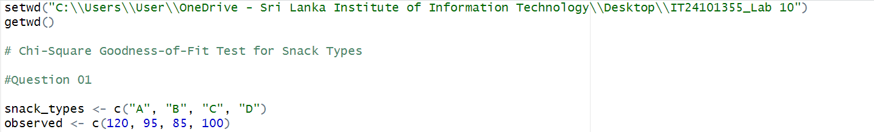

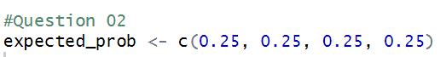ii. Perform a suitable chi-squared test to test the null hypothesis.



iii. Give your conclusions based on the results.

